**Software Requirement Specification (SRS)**

Of

**Training module**

For Implementation of

**Campus Management Software**

at

**World Skill Center (WSC)**

**Sustainable Outreach And Universal**

**Leadership (SOUL) Limited**

**Table of Contents**

A. Abstract 2

B. Introduction 3

C. Definition, Acronyms and Abbreviations 3

D. Overview of the Document 3

E. Scope of Training and Placement Module 3

F. WSC Training and Placement Process Flow 5

1. Seminar and Conference process flow and description

2. Internship process flow and description

G. List of Screens and their Descriptions 7

H. Training 8

1. TnP Program 8

2. TnP Event 9

3. Participant Registration 11

4. Participant Attendance 12

5. Event Feedback 14

6. Generate Certificate Tool 15

7. Generate Certificate 16

8. Placement Company 17

9. Internship Drive 19

10. Internship Application 21

11. Internship Participant Selection 23

12. Internship Final List Declaration 24

13. Internship Completion Status 25

# Abstract

Software Requirements Gathering is one of the first phases of system development. This phase results in the Software Requirements Specification (SRS) document, which must contain a complete, concise, high-quality description of the system being considered.

# Introduction

The World Skill Center (WSC) is a premier advanced skill training institute established by the Government of Odisha, Skill Development and Technical Education Department, through the Odisha Skill Development Authority (OSDA). The WSC will impart advanced skill training in eight trades from engineering and service sectors. WSC caters primarily to induct the best talent from ITIs and Polytechnics and train them to become globally employable in emerging areas such as "Industry 4.0". WSC is housed in a state-of-the-art, 18-storey, air-conditioned building with nearly half a million square feet of space in the heart of capital city of Bhubaneswar.

With the Implementation of campus management software for WSC the goal is to streamline the operations and functions of the campus by integrating various processes, such as admissions, course registration, academic progress tracking, and financial management, HRMS, Procurement and Inventory management, etc into a unified system. The implementation also aims at providing a user-friendly interface for all stakeholders, making it easier for them to access the necessary information and complete their tasks with ease. The modules to be covered during the implementation of the software includes:

|  |  |
| --- | --- |
| Students Management Modules | Infrastructure Management |
| Academic System | Finance and Accounting System |
| Procurement & Inventory Management | Training and Placement |
| Human Resources Management System | Application Integration |

# Definition, Acronyms and Abbreviations

The following table explains the terms and abbreviations used in the document:

|  |  |
| --- | --- |
| **Abbreviation** | **Description** |
| SRS | Software Requirements Specification |
| SLCM | Student Life Cycle Management |
| R | Rename - When a field is Renamed |
| N | New - When a New field is Added |
| D | Delete - When an Existing field is Deleted |
| NA | Not Applicable |
| TnP | Training and Placement |

# Overview of the Document

This requirement document provides a detailed overview of the functional requirements of a project. It serves as a communication tool between stakeholders, including developers, project managers, and end-users. The purpose of this requirement document is to define and document the project's objectives, scope, and expectations, and to ensure that all stakeholders have a clear understanding of what the project entails.

This document covers all the functional requirements of the Training module of the ERP product. THis module helps in organizing the entire training setup such as Participants Database, Application forms, Participant attendance etc.

# Scope of Training and Placement Module

* Seminars, Conferences and Internship organization and management
* Training program and event creation
* Participant selection
* Feedback recording
* Certificate generation
* Attendance recording

Following functionalities are covered in this SRS document:

* **Training Program Creation**
* **Training Event Creation**
* **Event Registration**
* **Attendance Recording**
* **Feedback Recording**
* **Certificate Generation**
* **Internship Declaration**
* **Internship Application**
* **Application shortlisting**

# WSC Training and Placement Process Flow

1. **Seminars and Conferences Process flow and description**

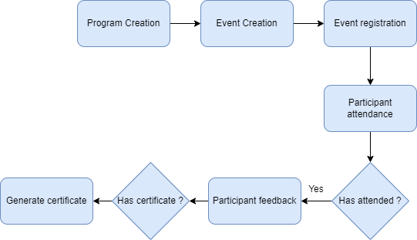

Fig : Seminar and Conferences Process Flow

**Program Creation**

This allows the user to create and maintain records of a TnP Program which is composed of different TnP Events in the system.

**Event creation**

This allows the user to create and maintain records of a TnP event which can be put in a program in the system.

**Event registration**

This allows the user to create and maintain records of registration forms for an event.

**Participant attendance**

This allows the user to record attendance of participants during an event and maintain the record in the system

**Participant feedback**

This allows the user to collect and maintain the records of the feedback submitted by the participants of an event in the system.

**Generate certificate**

This allows the user to generate certificates for the participants who have attended the event.

1. **Internship Process flow and description**

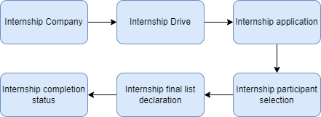

Fig : Internship Process Flow

**Internship Company**

This allows the use to create and maintain records of a company that is interested in conducting an internship drive in WSC.

**Internship Drive**

This allows the user to create an internship drive for a company.

**Internship Application**

This allows the user to create an application which will be used by the participants to Apply for an internship that they are eligible for.

**Internship Participant Selection**

This allows the user to select participants from all who applied for a drive.

**Internship Final List Declaration**

This allows the user to declare the list of applicants who will be allowed to participate in an internship.

**Internship Completion Status**

This allows the user to mark and maintain records of participants with regards to whether they completed an internship or not.

# List of Screens and their Descriptions

The following tables lists the pages used in ToT module :

|  |  |  |
| --- | --- | --- |
| **Sl no** | **Screen Name** | **Description** |
|  | TnP Program | It is a program which is comprised of one or more TNP events. |
|  | TnP Events | A TnP Event is an event in which the organizations students and faculty can participate. |
|  | Participant Registration | This allows the user to create a registration form which will be used by qualified individuals to apply for an event. The records of each registration is also maintained in this screen. |
|  | Participant Attendance | This allows the user to mark and keep track of the attendance of the participants in an event. |
|  | Event Feedback | **This allows a participant to submit feedback for an event that they attended.** |
|  | Generate Certificate Tool | This allows the user to generate certificates for all qualifying participants of an event at the same time. |
|  | Generate Certificate | This allows the user to generate certificates for qualifying participants of an event. |
|  | Placement Company | This allows the user create and maintain the records of companies who want to offer internships to the students of WSC. |
|  | Internship Drive | This allows the user to create one or more internship drives for a company offering internships to WSC students. |
|  | Internship Application | This allows the students to apply for an internship drive that they qualified for and are interested in. |
|  | Internship Participant Selection | This allows the user to select participants from those who applied for an internship drive. |
|  | Internship Final List Declaration | This allows the user to publish the final list of participants chosen |
|  | Internship Completion Status | This allows the user to mark and record the completion status of a participant regarding an event. |

# Training

Following are the screens used to achieve the functionalities of Training

### TnP Program

**General Description**

The following table describes overall information about this screen:

|  |  |  |
| --- | --- | --- |
| **Description** | | A TnP Program is an event that comprises of one or multiple TnP Event. |
| **Navigation** | Home > Training and Placement > Seminar and Conferences > TnP Program | |
| **Pre-requisites** | NA | |
| **Existing Screen Name** | NA | |
| **New Screen Name** | TnP Program | |

**Screenshot**

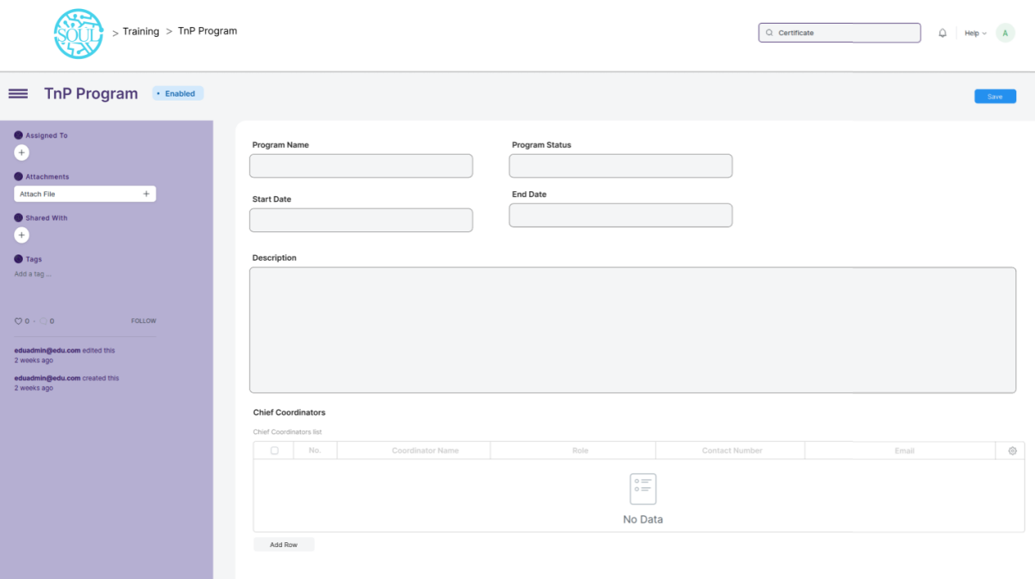

**Field List**

The following table describes the UI fields present in this screen :

|  |  |  |  |  |  |  |
| --- | --- | --- | --- | --- | --- | --- |
| **ID** | **Field Name** | **Field Type** | **Mandatory** | **Validation/ Action** | **Remarks** | **R/N/D** |
| 1 | Program Name | Data | Yes |  |  |  |
| 2 | Program Status | SELECT | Yes | Options :   1. Scheduled 2. Completed 3. Cancelled |  |  |
| 3 | Start Date | Date | Yes |  |  |  |
| 4 | End Date | Date | Yes |  |  |  |
| 5 | Description | Text Editor | Yes |  |  |  |
| 6 | Chief Coordinators | Table | Yes |  |  |  |
| **Chief Coordinators Table** | | | | | | |
| 7 | Coordinatior Name | Data | Yes |  |  |  |
| 8 | Role | Data | Yes |  |  |  |
| 9 | Contact number | Phone | Yes |  |  |  |
| 10 | Email | Email | Yes |  |  |  |

**User: Roles & Permission**

The following table describes the users and their roles and permissions for the screens :

|  |  |  |  |  |  |  |  |  |
| --- | --- | --- | --- | --- | --- | --- | --- | --- |
| **ID** | **Role** | **Read** | **Write** | **Create** | **Delete** | **Submit** | **Cancel** | **Amend** |
| 1 | Training and Placement Administrator | Yes | Yes | Yes | Yes | NA | NA | NA |
| 2 | Student | Yes | No | No | No | NA | NA | NA |

### TnP Event

**General Description**

The following table describes overall information about this screen:

|  |  |  |
| --- | --- | --- |
| **Description** | | A TnP event is an event which can be an individual part of a TnP Program and be scheduled within the program or can be a stand alone event that can be scheduled on its own time. |
| **Navigation** | Home > Training and Placement > Seminar and Conferences > TnP Event | |
| **Pre-requisites** | NA | |
| **Existing Screen Name** | NA | |
| **New Screen Name** | TnP Event | |

**Screenshot**

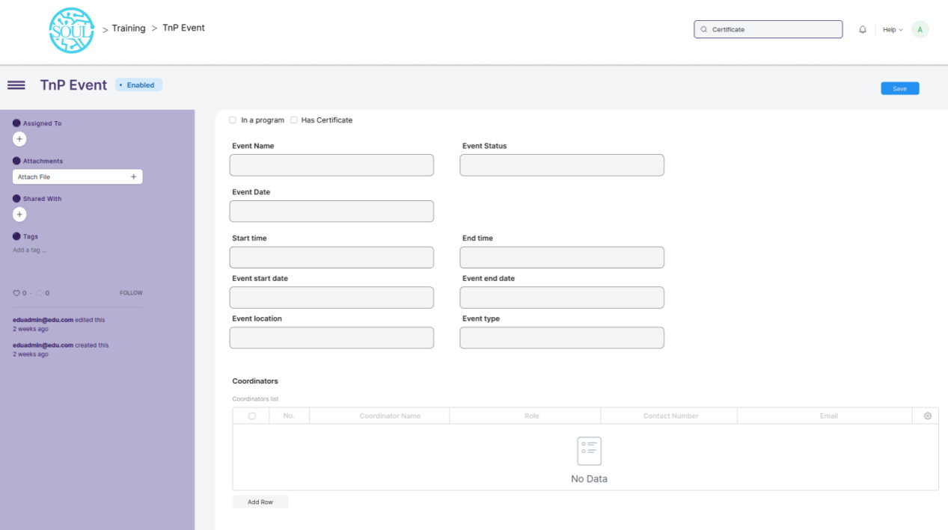

**Field List**

The following table describes the UI fields present in this screen :

|  |  |  |  |  |  |  |
| --- | --- | --- | --- | --- | --- | --- |
| **ID** | **Field Name** | **Field Type** | **Mandatory** | **Validation/ Action** | **Remarks** | **R/N/D** |
| 1 | Event Name | Data | Yes |  |  |  |
| 2 | Event Status | Select | Yes | Options :   1. Scheduled 2. Completed 3. Cancelled |  |  |
| 3 | Event Date | Date | Yes |  |  |  |
| 4 | Event Duration | Number | Yes |  |  |  |
| 5 | Start Time | Datetime | Yes |  |  |  |
| 6 | End Time | Datetime | Yes |  |  |  |
| 7 | Event Start Date | Date | Yes |  |  |  |
| 8 | Event End Date | Date | Yes |  |  |  |
| 9 | Event Location | Link | Yes |  |  |  |
| 10 | Event type | Select | Yes |  |  |  |
| 11 | Coordinators | Table | Yes |  |  |  |
| 12 | In a program | Check | Yes |  |  |  |
| 13 | Has certificate | Check | Yes |  |  |  |
| **Coordinators Table** | | | | | | |
| 7 | Coordinatior Name | Data | Yes |  |  |  |
| 8 | Role | Data | Yes |  |  |  |
| 9 | Contact number | Phone | Yes |  |  |  |
| 10 | Email | Email | Yes |  |  |  |

**User: Roles & Permission**

The following table describes the users and their roles and permissions for the screens :

|  |  |  |  |  |  |  |  |  |
| --- | --- | --- | --- | --- | --- | --- | --- | --- |
| **ID** | **Role** | **Read** | **Write** | **Create** | **Delete** | **Submit** | **Cancel** | **Amend** |
| 1 | Training and Placement Administrator | Yes | Yes | Yes | Yes | NA | NA | NA |
| 2 | Student | Yes | No | No | No | NA | NA | NA |

### Participant Registration

**General Description**

The following table describes overall information about this screen:

|  |  |  |
| --- | --- | --- |
| **Description** | | Participant Registration is a form that will be provided to individuals to register for an event. It maintains the records of all the Registrations made for TnP events using the system. |
| **Navigation** | Home > Training and Placement > Seminar and Conferences > Participant Registration | |
| **Pre-requisites** | NA | |
| **Existing Screen Name** | NA | |
| **New Screen Name** | Participant Registration | |

**Screenshot**

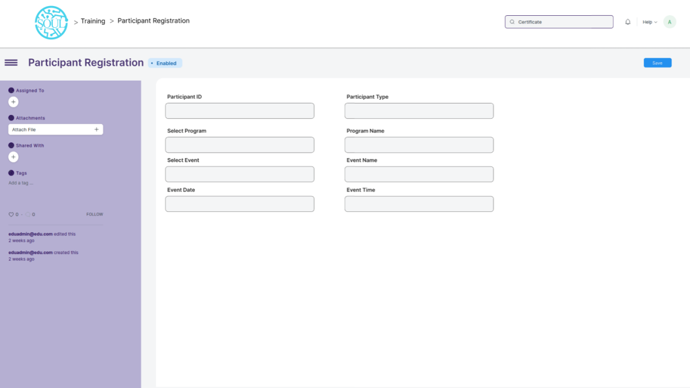

**Field List**

The following table describes the UI fields present in this screen :

|  |  |  |  |  |  |  |
| --- | --- | --- | --- | --- | --- | --- |
| **ID** | **Field Name** | **Field Type** | **Mandatory** | **Validation/ Action** | **Remarks** | **R/N/D** |
| 1 | Participant ID | Link | Yes |  |  |  |
| 2 | Participant Type | Select | Yes | Options:   1. Student 2. Employee |  |  |
| 3 | Select Program | Link | Yes |  |  |  |
| 4 | Program Name | Data | Yes |  |  |  |
| 5 | Select Event | Link | Yes |  |  |  |
| 6 | Event Name | Data | Yes |  |  |  |
| 7 | Event Date | Date | Yes |  |  |  |
| 8 | Event Time | Datetime | Yes |  |  |  |

**User: Roles & Permission**

The following table describes the users and their roles and permissions for the screens :

|  |  |  |  |  |  |  |  |  |
| --- | --- | --- | --- | --- | --- | --- | --- | --- |
| **ID** | **Role** | **Read** | **Write** | **Create** | **Delete** | **Submit** | **Cancel** | **Amend** |
| 1 | Training and Placement Administrator | Yes | Yes | Yes | Yes | Yes | NA | NA |
| 2 | Student | Yes | Yes | Yes | Yes | Yes | NA | NA |

### Participant Attendance

**General Description**

The following table describes overall information about this screen:

|  |  |
| --- | --- |
| **Description** | This screen is used to mark and maintain records of attendance for participants during a TnP event. |
| **Navigation** | Home > Training and Placement > Seminar and Conferences > Participant Attendance |
| **Pre-requisites** | NA |
| **Existing Screen Name** | NA |
| **New Screen Name** | Participant Attendance |

**Screenshot**

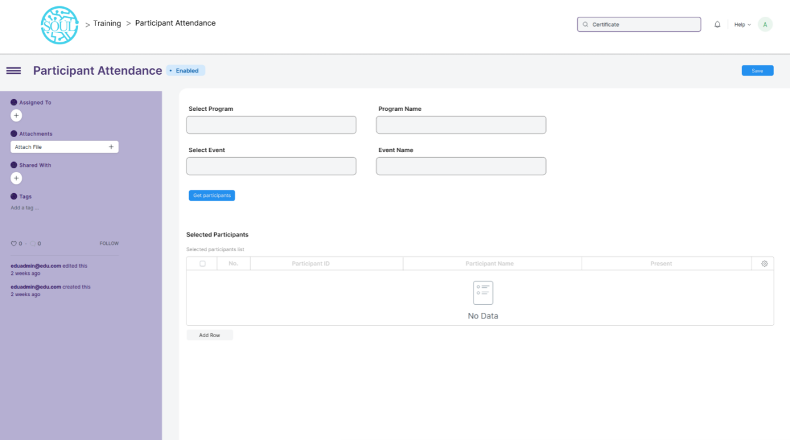

**Field List**

The following table describes the UI fields present in this screen :

|  |  |  |  |  |  |  |
| --- | --- | --- | --- | --- | --- | --- |
| **ID** | **Field Name** | **Field Type** | **Mandatory** | **Validation/ Action** | **Remarks** | **R/N/D** |
| 1 | Select Program | Link | Yes |  |  |  |
| 2 | Program Name | Data | Yes |  |  |  |
| 3 | Select Event | Link |  |  |  |  |
| 4 | Event Name | Data |  |  |  |  |
| 5 | Get Participants | Button |  |  |  |  |
| 6 | Selected Participants | Table | Yes |  |  |  |
| **Participant Table** | | | | | | |
| 7 | Participant ID | Data | Yes |  |  |  |
| 8 | Participant Name | Data | Yes |  |  |  |
| 9 | Present | Select | Yes | Options:   1. Present 2. Absent |  |  |

**User: Roles & Permission**

The following table describes the users and their roles and permissions for the screens :

|  |  |  |  |  |  |  |  |  |
| --- | --- | --- | --- | --- | --- | --- | --- | --- |
| **ID** | **Role** | **Read** | **Write** | **Create** | **Delete** | **Submit** | **Cancel** | **Amend** |
| 1 | Training and Placement Administrator | Yes | Yes | Yes | Yes | Yes | NA | NA |
| 2 | Student | Yes | No | No | No | Yes | NA | NA |

### Event Feedback

**General Description**

The following table describes overall information about this screen:

|  |  |  |
| --- | --- | --- |
| **Description** | | This screen is provided to the participants for recording their feedback regarding a TnP Event. |
| **Navigation** | Home > Training and Placement > Seminar and Conferences > Event Feedback | |
| **Pre-requisites** | NA | |
| **Existing Screen Name** | NA | |
| **New Screen Name** | Event Feedback | |

**Screenshot**

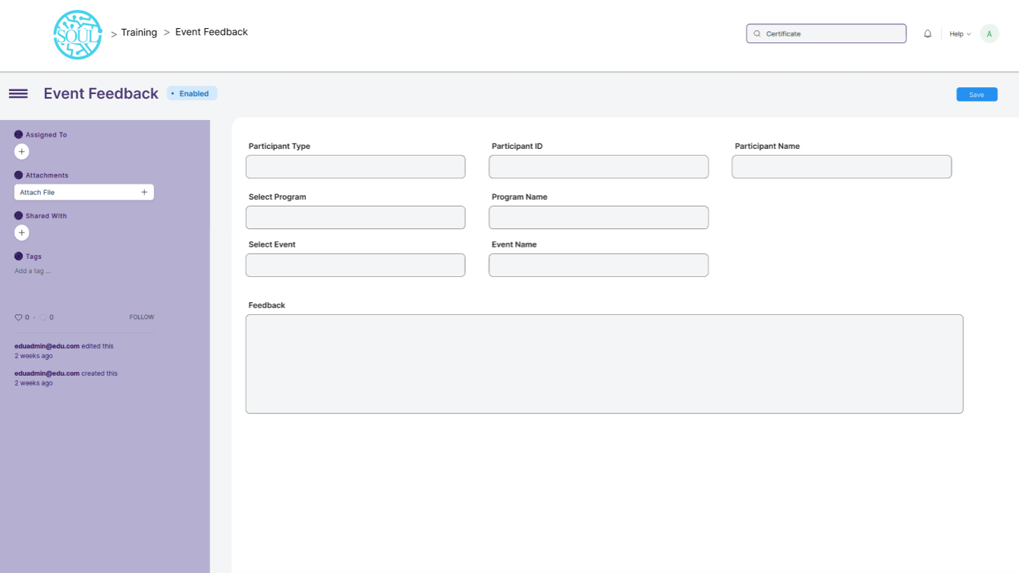

**Field List**

The following table describes the UI fields present in this screen :

|  |  |  |  |  |  |  |
| --- | --- | --- | --- | --- | --- | --- |
| **ID** | **Field Name** | **Field Type** | **Mandatory** | **Validation/ Action** | **Remarks** | **R/N/D** |
| 1 | Participant Type | Select | Yes | Options:   1. Student 2. Employee |  |  |
| 2 | Participant ID | Dynamic Link | Yes |  |  |  |
| 3 | Participant Name | Data | Yes |  |  |  |
| 4 | Select Program | Link | Yes |  |  |  |
| 5 | Program Name | Data | Yes |  |  |  |
| 6 | Select Event | Link | Yes |  |  |  |
| 7 | Event Name | Data | Yes |  |  |  |
| 8 | Feedback | Text editor | Yes |  |  |  |

**User: Roles & Permission**

The following table describes the users and their roles and permissions for the screens :

|  |  |  |  |  |  |  |  |  |
| --- | --- | --- | --- | --- | --- | --- | --- | --- |
| **ID** | **Role** | **Read** | **Write** | **Create** | **Delete** | **Submit** | **Cancel** | **Amend** |
| 1 | Training and Placement Administrator | Yes | Yes | Yes | Yes | Yes | NA | NA |
| 2 | Student | Yes | Yes | Yes | No | Yes | NA | NA |

### Generate Certificate Tool

**General Description**

The following table describes overall information about this screen:

|  |  |  |
| --- | --- | --- |
| **Description** | | This screen is used by the user to generate certificates in bulk for the eligible participants of an event.. |
| **Navigation** | Home > Training and Placement > Seminar and Conferences > Generate Certificate Tool | |
| **Pre-requisites** | NA | |
| **Existing Screen Name** | NA | |
| **New Screen Name** | Generate Certificate Tool | |

**Screenshot**

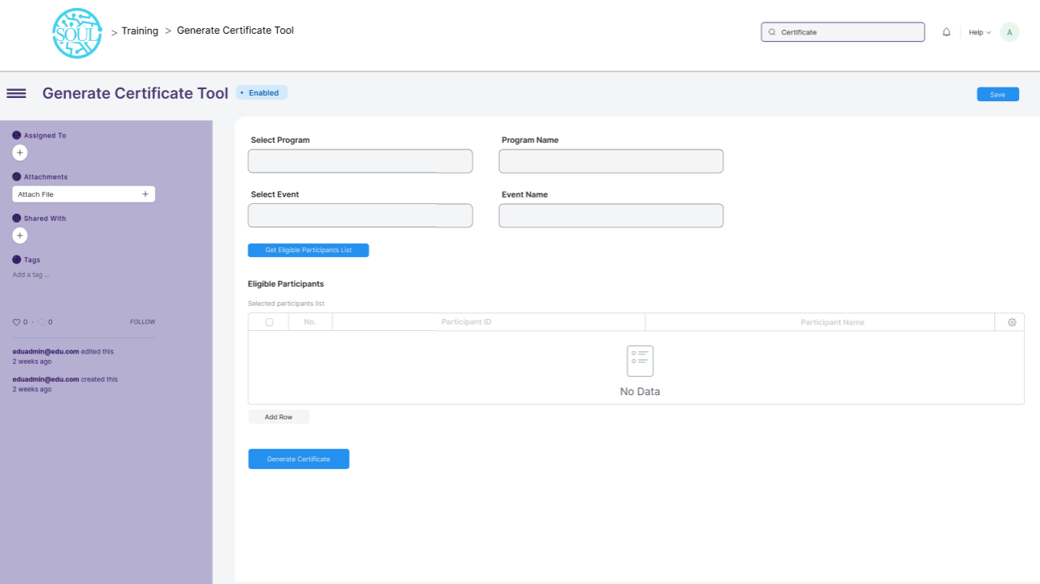

**Field List**

The following table describes the UI fields present in this screen :

|  |  |  |  |  |  |  |
| --- | --- | --- | --- | --- | --- | --- |
| **ID** | **Field Name** | **Field Type** | **Mandatory** | **Validation/ Action** | **Remarks** | **R/N/D** |
| 1 | Select Program | Link | Yes |  |  |  |
| 2 | Program Name | Data | Yes |  |  |  |
| 3 | Select Event | Link |  |  |  |  |
| 4 | Event Name | Data |  |  |  |  |
| 5 | Get Eligible Participants List | Button | Yes |  |  |  |
| 6 | Eligible Participants | Table | Yes |  |  |  |
| **Eligible Participants Table** | | | | | | |
| 7 | Participant ID | Data | Yes |  |  |  |
| 8 | Participant Name | Data | Yes |  |  |  |

**User: Roles & Permission**

The following table describes the users and their roles and permissions for the screens :

|  |  |  |  |  |  |  |  |  |
| --- | --- | --- | --- | --- | --- | --- | --- | --- |
| **ID** | **Role** | **Read** | **Write** | **Create** | **Delete** | **Submit** | **Cancel** | **Amend** |
| 1 | Training and Placement Administrator | Yes | Yes | Yes | Yes | NA | NA | NA |

### Generate Certificate

**General Description**

The following table describes overall information about this screen:

|  |  |  |
| --- | --- | --- |
| **Description** | | The screen is used to generate certificate for participants of an event who are eligible for it. |
| **Navigation** | Home > Training and Placement > Seminar and Conferences > Generate Certificate | |
| **Pre-requisites** | NA | |
| **Existing Screen Name** | NA | |
| **New Screen Name** | Generate Certificate | |

**Screenshot**

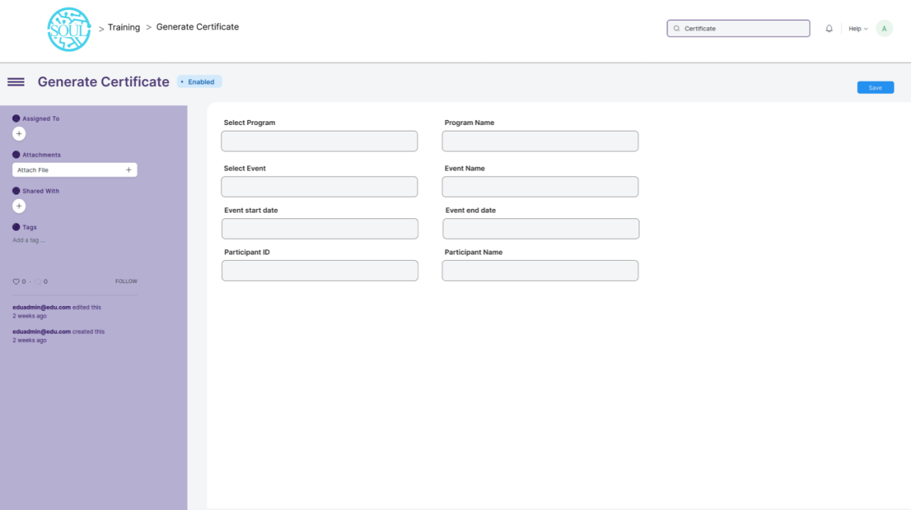

**Field List**

The following table describes the UI fields present in this screen :

|  |  |  |  |  |  |  |
| --- | --- | --- | --- | --- | --- | --- |
| **ID** | **Field Name** | **Field Type** | **Mandatory** | **Validation/ Action** | **Remarks** | **R/N/D** |
| 1 | Select Program | Link | Yes |  |  |  |
| 2 | Program Name | Data | Yes |  |  |  |
| 3 | Select Event | Link | Yes |  |  |  |
| 4 | Event Name | Data | Yes |  |  |  |
| 5 | Event Start Date | Date | Yes |  |  |  |
| 6 | Event End Date | Date | Yes |  |  |  |
| 7 | Participant Type | Select | Yes | Options :   1. Student 2. Employee |  |  |
| 8 | Participant ID | Data | Yes |  |  |  |
| 9 | Participant Name | Data | Yes |  |  |  |

**User: Roles & Permission**

The following table describes the users and their roles and permissions for the screens :

|  |  |  |  |  |  |  |  |  |
| --- | --- | --- | --- | --- | --- | --- | --- | --- |
| **ID** | **Role** | **Read** | **Write** | **Create** | **Delete** | **Submit** | **Cancel** | **Amend** |
| 1 | Training and Placement Administrator | Yes | Yes | Yes | Yes | NA | NA | NA |

### Placement Company

**General Description**

The following table describes overall information about this screen:

|  |  |  |
| --- | --- | --- |
| **Description** | | This screen is used to record the details of a company who has shown interest in offering internships to WSC students. |
| **Navigation** | Home > Training and Placement > Internship > Placement Company | |
| **Pre-requisites** | NA | |
| **Existing Screen Name** | NA | |
| **New Screen Name** | Placement Company | |

**Screenshot**

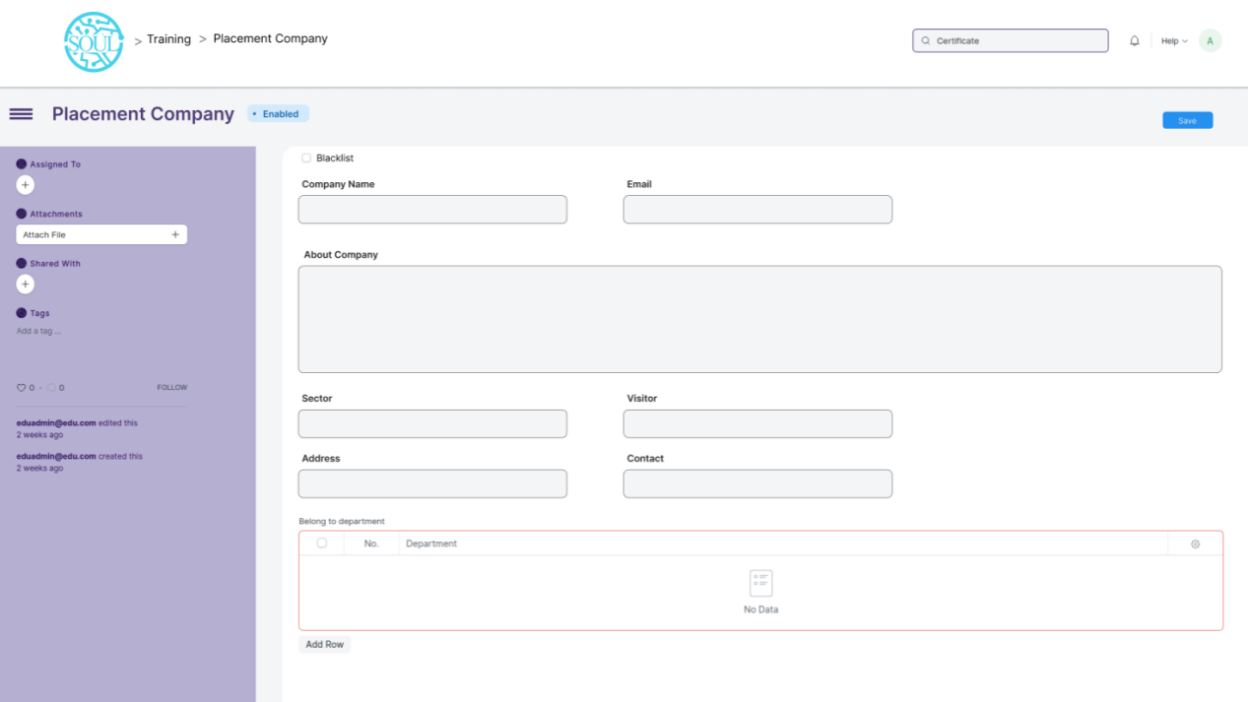

**Field List**

The following table describes the UI fields present in this screen :

|  |  |  |  |  |  |  |
| --- | --- | --- | --- | --- | --- | --- |
| **ID** | **Field Name** | **Field Type** | **Mandatory** | **Validation/ Action** | **Remarks** | **R/N/D** |
| 1 | Blacklist | Checkbox | Yes |  |  |  |
| 2 | Company Name | Data | Yes |  |  |  |
| 3 | Email | Email | Yes |  |  |  |
| 4 | About company | Text editor | Yes |  |  |  |
| 5 | Sector | Link | Yes |  |  |  |
| 6 | Visitor | Select | Yes | Options:   1. Normal visitor 2. Internship |  |  |
| 7 | Address | HTML | Yes |  |  |  |
| 8 | Contact | HTML | Yes |  |  |  |
| 9 | Department | Table | Yes |  |  |  |
| **Belong to department Table** | | | | | | |
| 10 | Department | Link | Yes |  |  |  |

**User: Roles & Permission**

The following table describes the users and their roles and permissions for the screens :

|  |  |  |  |  |  |  |  |  |
| --- | --- | --- | --- | --- | --- | --- | --- | --- |
| **ID** | **Role** | **Read** | **Write** | **Create** | **Delete** | **Submit** | **Cancel** | **Amend** |
| 1 | Training and Placement Administrator | Yes | Yes | Yes | Yes | NA | NA | NA |

### Internship Drive

**General Description**

The following table describes overall information about this screen:

|  |  |  |
| --- | --- | --- |
| **Description** | | This screen is used to create and maintain the records of various internship drives to which the students will apply. |
| **Navigation** | Home > Training and Placement > Internship > Internship Drive | |
| **Pre-requisites** | NA | |
| **Existing Screen Name** | NA | |
| **New Screen Name** | Internship Drive | |

**Screenshot**

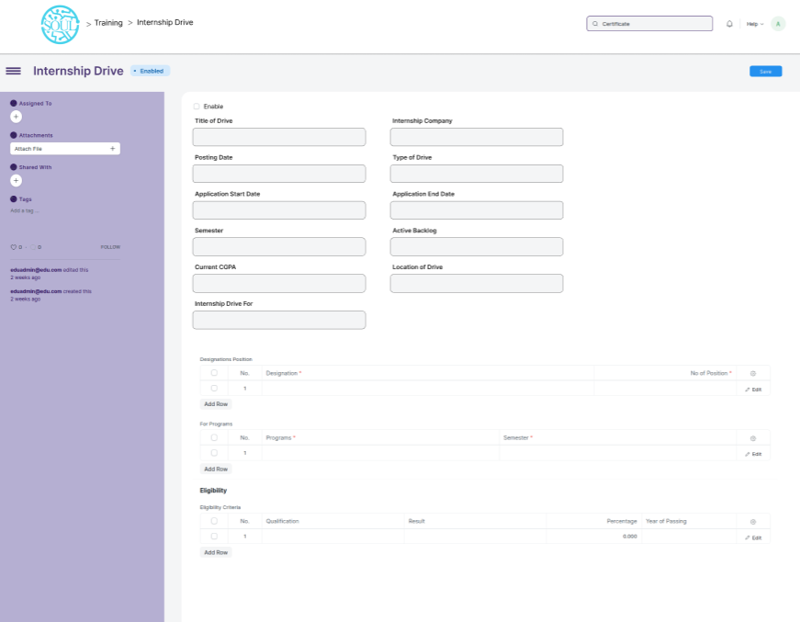

**Field List**

The following table describes the UI fields present in this screen :

|  |  |  |  |  |  |  |
| --- | --- | --- | --- | --- | --- | --- |
| **ID** | **Field Name** | **Field Type** | **Mandatory** | **Validation/ Action** | **Remarks** | **R/N/D** |
| 1 | Enable | Checkbox | Yes |  |  |  |
| 2 | Drive Title | Data | Yes |  |  |  |
| 3 | Posting Date | Date | Yes |  |  |  |
| 4 | Internship Company | Link | Yes |  |  |  |
| 5 | Semester | Link | Yes |  |  |  |
| 6 | Current CGPA | Data | Yes |  |  |  |
| 7 | Active Backlog | Number | Yes |  |  |  |
| 8 | Type of Drive | Select | Yes | Options:   1. In Campus 2. Off campus |  |  |
| 9 | Location of Drive | Link | Yes |  |  |  |
| 10 | Internship Drive For | Select | Yes | Options:   1. Freshers |  |  |
| 11 | Application Start Date | Date | Yes |  |  |  |
| 12 | Application End Date | Date | Yes |  |  |  |
| 13 | IsPaid | Checkbox | Yes |  |  |  |
| 14 | CTC | Data | Yes |  |  |  |
| 15 | Joining Type | Select | Yes | Options:   1. Immediate 2. Non-immediate |  |  |
| 16 | Type of Job | Select | Yes | Options:   1. Internship |  |  |
| **Designation Table** | | | | | | |
| 17 | Designation | Link | Yes |  |  |  |
| 18 | No. of Position | Number | Yes |  |  |  |
| **For Programs Table** | | | | | | |
| 19 | Programs | Link | Yes |  |  |  |
| 20 | Semester | Link | Yes |  |  |  |
| **Eligibility Criteria Table** | | | | | | |
| 21 | Qualification | SELECT | Yes | Options:   1. 10th 2. 12th |  |  |
| 22 | Result | Data | Yes |  |  |  |
| 23 | Percentage | Data | Yes |  |  |  |
| 24 | Year of Passing | Date | Yes |  |  |  |

**User: Roles & Permission**

The following table describes the users and their roles and permissions for the screens :

|  |  |  |  |  |  |  |  |  |
| --- | --- | --- | --- | --- | --- | --- | --- | --- |
| **ID** | **Role** | **Read** | **Write** | **Create** | **Delete** | **Submit** | **Cancel** | **Amend** |
| 1 | Training and Placement Administrator | Yes | Yes | Yes | Yes | NA | NA | NA |
| 2 | Student | Yes | No | No | No | NA | NA | NA |

### Internship Application

**General Description**

The following table describes overall information about this screen:

|  |  |  |
| --- | --- | --- |
| **Description** | | This screen is used for creating applications which will be used by the students for applying to an internship drive. |
| **Navigation** | Home > Training and Placement > Internship > Internship Application | |
| **Pre-requisites** | NA | |
| **Existing Screen Name** | NA | |
| **New Screen Name** | Internship Application | |

**Screenshot**

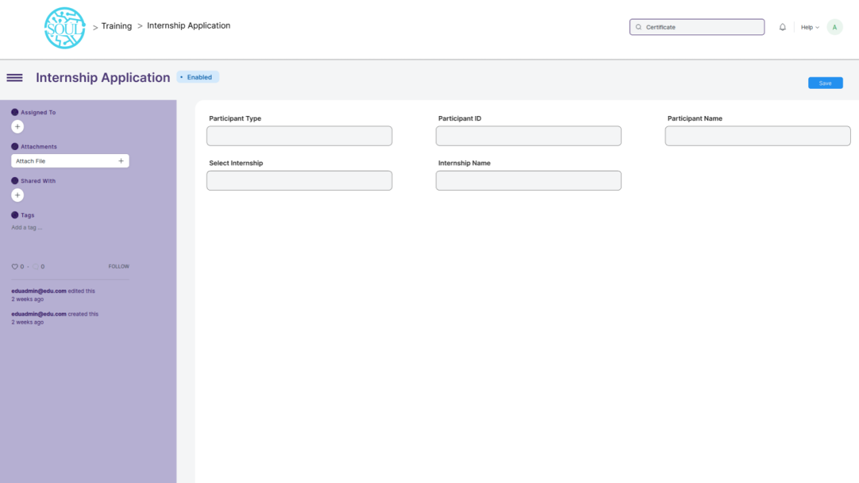

**Field List**

The following table describes the UI fields present in this screen :

|  |  |  |  |  |  |  |
| --- | --- | --- | --- | --- | --- | --- |
| **ID** | **Field Name** | **Field Type** | **Mandatory** | **Validation/ Action** | **Remarks** | **R/N/D** |
| 1 | Participant Type | Select | Yes | Options :   1. Student 2. Employee |  |  |
| 2 | Participant ID | Link | Yes |  |  |  |
|  | Participant Name | Data | Yes |  |  |  |
| 3 | Select Internship | Link | Yes |  |  |  |
| 4 | Internship Name | Data | Yes |  |  |  |

**User: Roles & Permission**

The following table describes the users and their roles and permissions for the screens :

|  |  |  |  |  |  |  |  |  |
| --- | --- | --- | --- | --- | --- | --- | --- | --- |
| **ID** | **Role** | **Read** | **Write** | **Create** | **Delete** | **Submit** | **Cancel** | **Amend** |
| 1 | Training and Placement Administrator | Yes | Yes | Yes | Yes | Yes | NA | NA |
| 2 | Student | Yes | Yes | Yes | No | Yes | NA | NA |

### Internship Participant Selection

**General Description**

The following table describes overall information about this screen:

|  |  |  |
| --- | --- | --- |
| **Description** | | This screen is used to select and create the final list of students who will be selected for an internship. |
| **Navigation** | Home > Training and Placement > Internship > Internship Participant Selection | |
| **Pre-requisites** | NA | |
| **Existing Screen Name** | NA | |
| **New Screen Name** | Internship Participant Selection | |

**Screenshot**

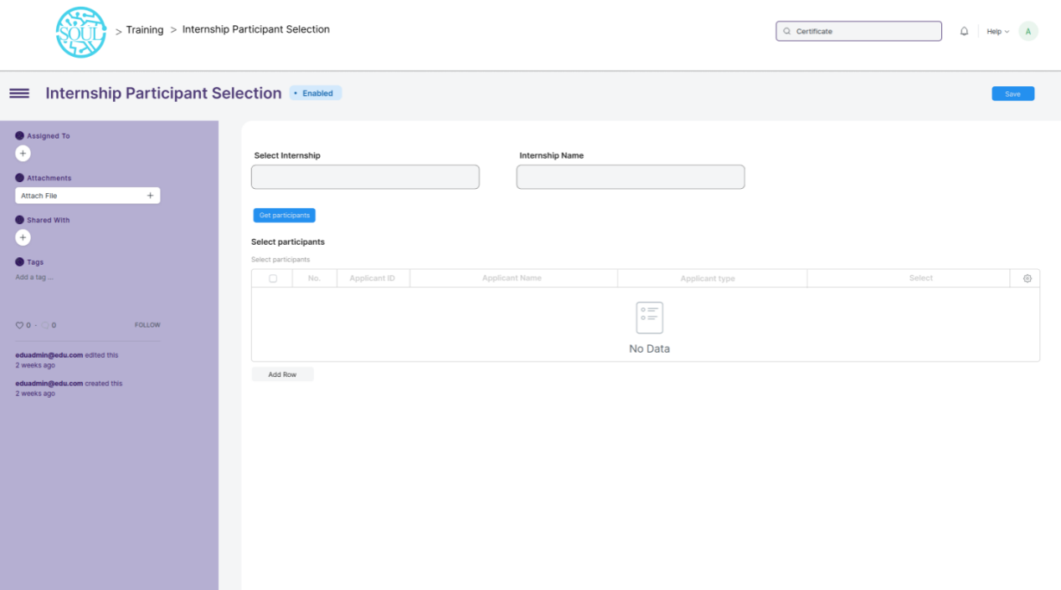

**Field List**

The following table describes the UI fields present in this screen :

|  |  |  |  |  |  |  |
| --- | --- | --- | --- | --- | --- | --- |
| **ID** | **Field Name** | **Field Type** | **Mandatory** | **Validation/ Action** | **Remarks** | **R/N/D** |
| 1 | Select Internship | Link | Yes |  |  |  |
| 2 | Internship Name | Data | Yes |  |  |  |
| 3 | Get Participants | Button | Yes |  |  |  |
| 4 | Select participants | Table |  |  |  |  |
| **Select Participants Table** | | | | | | |
| 6 | Applicant ID | Data | Yes |  |  |  |
| 7 | Applicant Name | Data | Yes |  |  |  |
| 8 | Course | Data | Yes |  |  |  |
| 9 | Select | Data | Yes |  |  |  |

**User: Roles & Permission**

The following table describes the users and their roles and permissions for the screens :

|  |  |  |  |  |  |  |  |  |
| --- | --- | --- | --- | --- | --- | --- | --- | --- |
| **ID** | **Role** | **Read** | **Write** | **Create** | **Delete** | **Submit** | **Cancel** | **Amend** |
| 1 | Training and Placement Administrator | Yes | Yes | Yes | Yes | NA | NA | NA |
| 2 | Student | Yes | No | No | No | NA | NA | NA |

### Internship Final List Declaration

**General Description**

The following table describes overall information about this screen:

|  |  |  |
| --- | --- | --- |
| **Description** | | This screen is used to declare the list of applicants who have been chosen for an internship drive. |
| **Navigation** | Home > Training and Placement > Internship > Internship Final List Declaration | |
| **Pre-requisites** | NA | |
| **Existing Screen Name** | No Change | |
| **New Screen Name** | Internship Final List Declaration | |

**Screenshot**

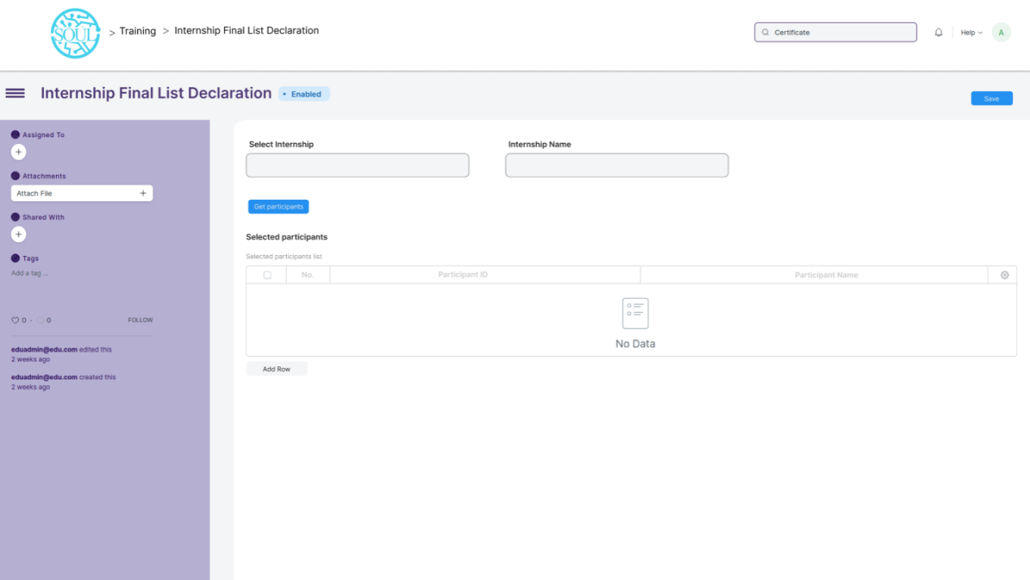

**Field List**

The following table describes the UI fields present in this screen :

|  |  |  |  |  |  |  |
| --- | --- | --- | --- | --- | --- | --- |
| **ID** | **Field Name** | **Field Type** | **Mandatory** | **Validation/ Action** | **Remarks** | **R/N/D** |
| 1 | Select Internship | Link | Yes |  |  |  |
| 2 | Internship Name | Data | Yes |  |  |  |
| 3 | Selected participants | Button | Yes |  |  |  |
| **Selected participants Table** | | | | | | |
| 4 | Participant ID | Data | Yes |  |  |  |
| 5 | Participant Name | Data | Yes |  |  |  |

**User: Roles & Permission**

The following table describes the users and their roles and permissions for the screens :

|  |  |  |  |  |  |  |  |  |
| --- | --- | --- | --- | --- | --- | --- | --- | --- |
| **ID** | **Role** | **Read** | **Write** | **Create** | **Delete** | **Submit** | **Cancel** | **Amend** |
| 1 | Training and Placement Administrator | Yes | Yes | Yes | Yes | NA | NA | NA |
| 2 | Student | Yes | No | No | No | NA | NA | NA |

### Internship Completion Status

**General Description**

The following table describes overall information about this screen:

|  |  |  |
| --- | --- | --- |
| **Description** | | This screen is used for recording whether a student has completed an Internship they participated in or not. |
| **Navigation** | Home > Training and Placement > Internship > Internship Completion Status | |
| **Pre-requisites** | NA | |
| **Existing Screen Name** | NA | |
| **New Screen Name** | Internship Completion Status | |

**Screenshot**

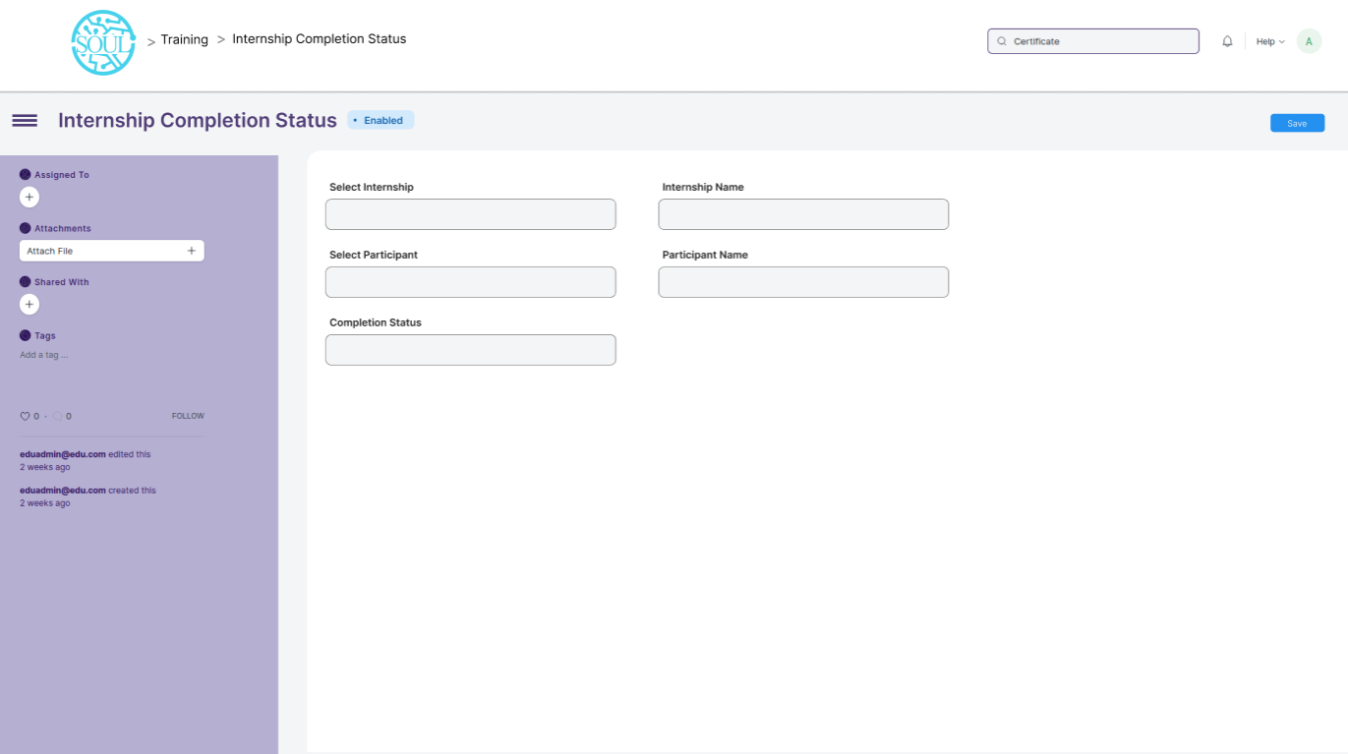

**Field List**

The following table describes the UI fields present in this screen :

|  |  |  |  |  |  |  |
| --- | --- | --- | --- | --- | --- | --- |
| **ID** | **Field Name** | **Field Type** | **Mandatory** | **Validation/ Action** | **Remarks** | **R/N/D** |
| 1 | Select Internship | Link | Yes |  |  |  |
| 2 | Internship Name | Data | Yes |  |  |  |
| 3 | Select Participant | Link | Yes |  |  |  |
| 4 | Participant Name | Data | Yes |  |  |  |
| 5 | Completion Status | Select | Yes | Options:   1. Completed 2. Not completed |  |  |

**User: Roles & Permission**

The following table describes the users and their roles and permissions for the screens :

|  |  |  |  |  |  |  |  |  |
| --- | --- | --- | --- | --- | --- | --- | --- | --- |
| **ID** | **Role** | **Read** | **Write** | **Create** | **Delete** | **Submit** | **Cancel** | **Amend** |
| 1 | Training and Placement Administrator | Yes | Yes | Yes | Yes | NA | NA | NA |